Annexure 1

Project Report
on

“Bloomybay (bloomybay.netlify.app)"

Floweraura

A Field Project Report
Submitted in partial fulfillment of the requirements for the Award of the degree of

“Bachelor Of Computer Application”
By

Akash Mishra
(22307630063)



Centre for Distance and Online Education

LOVELY PROFESSIONAL UNIVERSITY, PHAGWARA, PUNJAB

2023-2026

Annexure - II:

Student Declaration

To whom so ever it may concern
I Akash Mishra (22307630063) , hereby declare that the work done by me on “” from 23/07/2025 to 22/09/2025, is a record of original work for the partial fulfillment of the requirements for the award of the degree, Bachelor Of Computer Application.

Akash Mishra (22307630063)



Signature of the student Dated: 25 sept,2025


INDEX

S.No | Contents | Page No.
1. | Abstract | 5
3. | Chapter-1  Introduction of the Project | 6
4. | Chapter-2  Introdution of the Organisation | 7
4. | Chapter-3  BRIEF DESCRIPTION OF WORK DONE | 8
5. | Chapter-4  Development process | 12
6. | Chapter-5  Analysis Document | 16
 | - SRS of online shopping store
 | - ER Diagram
 | - DFDs
 | - Data dictionary
 | - User authorities
 | - Admin authorities
7. | Chapter-6  Coding of client home page Maintenace | 31
8. | Final Conclusion | 52
9 | References | 44

ABSTRACT

The BloomyBay project aims to design and develop a modern, user-friendly e-commerce platform optimized for accessibility, aesthetic appeal, and customer satisfaction. This website combines the elegance of a gifting store with the convenience of online shopping, making it ideal for users seeking flowers, cakes, and gifts for every occasion. The design emphasizes a responsive interface, smooth navigation, and a vibrant yet professional look, focusing on affordability, simplicity, and engaging user experience.
The project integrates essential web technologies—HTML, CSS, and JavaScript—to deliver a seamless and interactive platform that adapts to both desktop and mobile users. Key considerations include performance, usability, and emotional design, ensuring that BloomyBay appeals to a wide audience, from individual gift shoppers to corporate clients.
Through structured development, testing, and design refinement, the BloomyBay project seeks to provide a practical and elegant digital solution that bridges the gap between traditional gift stores and modern online marketplaces.

.

CHAPTER-1 INTRODUCTION TO THE PROJECT

ABOUT PROJECT
The project, named BloomyBay, is a web-based e-commerce platform for a gifting company. This company primarily deals with flowers, cakes, and gift items.
In this software, all customer interactions and orders are collected and managed efficiently. When a user places an order, details such as customer name, contact information, chosen products, quantity, and delivery instructions are recorded with order status (e.g., Pending, Confirmed, Delivered). After order placement, the platform can send email confirmations to customers with product and payment details, ensuring smooth communication.
BloomyBay also stores all product information in organized catalogs, making it easy to add, update, delete, and retrieve product details. The platform is designed to be fast, user-friendly, and responsive, providing a seamless shopping experience for customers while simplifying management tasks for the company.

OBJECTIVES OF PROJECT

After thoroughly analyzing the requirements for an online gifting platform, the following objectives have been set:
a) Providing a user-friendly and visually appealing interface.
b) Storing and managing product and order data efficiently.
c) Collecting all information about products and customers in an organized way.
d) Ensuring easy access to product and order data for management.
e) Facilitating simple maintenance of website content and product catalogs.
f) Maintaining data consistency across all orders and product listings.
g) Providing better website performance and fast loading.
h) Increasing operational efficiency through automation of order processing and email confirmations.
i) Implementing adequate validation checks for user input (e.g., email, phone, payment details).
j) Allowing the ability to update product and customer data regularly.
k) Ensuring adequate security for customer data and transactions.

Scope of the Project

The scope of the BloomyBay project is to design, develop, and implement a comprehensive e-commerce platform for flowers, cakes, and gift items, enhancing both customer experience and operational efficiency. Key functions include:
Product Management: Collecting, storing, and updating detailed product information such as images, descriptions, prices, and stock availability.
Order Management: Tracking orders from placement to delivery, including status updates, payment confirmations, and email notifications.
Customer Data Management: Storing customer details like contact information, delivery addresses, and purchase history.
Marketing & Promotions: Running offers, discount campaigns, and featured product highlights to engage customers.
Analytics & Reporting: Providing dashboards and reports on orders, popular products, and customer activity to support business decision.

Importance and Applicability of the BloomyBay Project
- Enhanced Operational Efficiency:
The platform streamlines order management, product updates, and customer communication, reducing manual effort and improving workflow efficiency.
- Real-Time Order Tracking:
Customers and administrators can track orders, delivery status, and payment confirmations, ensuring transparency and timely service.
- Data-Driven Insights:
By analyzing customer preferences, product popularity, and sales trends, the platform supports marketing strategies and inventory planning.
- User-Friendly Interface:
A clean, intuitive interface ensures easy navigation for both customers and administrators, improving usability and customer satisfaction.
- Automation & Reliability:
Features like automated email confirmations, validation checks, and real-time stock updates increase reliability and reduce errors.

Applicability:
- Online Retail:
The platform is suitable for small to medium-sized businesses selling flowers, cakes, gifts, or other personalized products online.
- Customer Engagement:
Helps businesses interact with customers efficiently through emails, order updates, and promotions.
- E-Commerce Learning Platform:
Useful for students and developers to learn about frontend development, web design, and basic e-commerce functionality.
- Marketing & Analytics:
Can be applied to track customer behavior, run targeted promotions, and measure product performance.
- Digital Transformation for Local Stores:
Local gift shops or bakeries can use the platform to expand online sales, manage orders, and increase reven

CHAPTER 2: INTRODUCTION OF THE ORGANIZATION

FlowerAura is one of India’s leading online gifting and flower delivery brands, established with the vision of making every occasion more special and memorable. Founded in 2010 under the parent company FA Gifts Pvt. Ltd., FlowerAura has emerged as a trusted name in the online gifting industry, offering a wide range of flowers, cakes, plants, chocolates, and personalized gifts across the country.
The organization’s primary objective is to deliver happiness through thoughtful gifts that express emotions “when words are not enough.” With a strong focus on quality, timely delivery, and customer satisfaction, FlowerAura has built a reputation for providing fresh, creative, and affordable gifting solutions for all kinds of celebrations — including birthdays, anniversaries, weddings, and festivals.
Over the years, FlowerAura has expanded its operations across 400+ cities in India, offering same-day and midnight delivery services. The brand leverages modern e-commerce technology, efficient logistics, and customer-centric design to ensure a smooth shopping experience.
The company’s success is driven by a dedicated team of designers, florists, and developers who work together to combine technology with creativity. By integrating digital innovation with emotional value, FlowerAura continues to enhance the way people connect and celebrate with their loved ones.
With its core values rooted in quality, trust, and innovation, FlowerAura has transformed traditional gifting into a modern, digital experience, becoming a symbol of love, care, and thoughtful expression across India.

CHAPTER 3

BRIEF DESCRIPTION OF WORK DONE

Position of Training and Roles
Position: Frontend Developer Intern
During the training period, my role focused on the design and development of a responsive e-commerce website named Floweraura, an online platform for ordering flowers, cakes, and gifts.
Key Responsibilities:
- Designed and developed interactive webpages using HTML, CSS, and JavaScript.
- Created a user-friendly product catalog with categories for flowers, cakes, and personalized gifts.
- Implemented responsive design using modern CSS frameworks to ensure compatibility across all devices.
- Integrated EmailJS API to send automated confirmation emails to users after placing an order.
- Worked on form validation, ensuring correct data input for checkout and contact forms.
- Collaborated in testing, debugging, and improving the site’s layout and functionality.
- Enhanced user experience through smooth animations, dynamic content loading, and optimized navigation.
Challenges Faced and How They Were Tackled
- Challenge: Designing an attractive and responsive interface for both desktop and mobile users.
Solution: Used flexible layouts with CSS media queries and tested responsiveness on multiple devices.
- Challenge: Sending confirmation emails to users automatically after an order is placed.
Solution: Integrated EmailJS service to connect the frontend with the email system for real-time communication.
- Challenge: Ensuring secure handling of user data during form submissions.
Solution: Implemented form validation using JavaScript and restricted access to sensitive information.
- Challenge: Organizing a large number of products with different images, prices, and descriptions.
Solution: Structured the product section using JSON-like data arrays and modular components for easy management.
- Challenge: Maintaining consistency in color themes, typography, and layout across all pages.
Solution: Created a style guide and reusable CSS classes for global design consistency.
- Challenge: Optimizing website loading speed with multiple high-quality product images.
Solution: Compressed images, used lazy loading, and optimized CSS/JS files.
- Challenge: Making the design appealing while keeping it professional and brand-aligned.
Solution: Followed the brand’s color palette (pastel pink, white, green) and used modern UI design principles.

Learning Outcomes
- Gained hands-on experience in developing dynamic, responsive web applications.
- Strengthened practical skills in HTML5, CSS3, JavaScript, and Bootstrap.
- Learned to design with a user-centric approach, improving navigation and aesthetics.
- Improved understanding of frontend validation, animations, and layout optimization.
- Developed skills in problem-solving, debugging, and responsive design testing.
- Understood the importance of version control, clean coding practices, and modular design.
- Experienced working on a real-world project, from planning to deployment.

Data Analysis
- Collected and stored customer data through online forms (e.g., name, email, delivery details).
- Processed user-submitted data using JavaScript logic and validation to ensure accuracy.
- Organized product data (name, category, price, image, description) into structured formats for easy retrieval.
- Implemented search and filter functions to help users find products quickly.
- Created summary sections for total orders, prices, and product statistics.
- Used loops, arrays, and conditional logic to dynamically display product information on webpages.
- Analyzed user interaction patterns to improve website navigation and layout.

CHAPTER 4 DEVELOPMENT PROCESS

Hardware Requirement:-
- Processor : Pentium Processor ISA 32 Family

- Secondary Storage : 80 GB HDD

- ROM : 52X CD ROM Drive
- Floppy Drive : 1.44 FDD
- Memory : 1 GB RAM

- Network Adapter : Ethernet Adapter
- Modem : 128kbps Voice Fax Data
- Others : 17" Color Monitor, Printer, Scanner,
: Keyboard, Mouse

Software Requirement
- MS Access 2007

- Programming Language(VB.Net 2008)

TOOLS

Visual Studio

Microsoft Visual Studio 20008 Version 8.0.30319.1 RTMRel Microsoft .NET Framework Version 4.0.30319 RTMRel

Installed Version: Ultimate

Microsoft Office Developer Tools 01019-532-2002102-70237 Microsoft Office Developer Tools

Microsoft Visual Basic 2008 01019-532-2002102-70237 Microsoft Visual Basic 2008

Microsoft Visual C# 2008 01019-532-2002102-70237
Microsoft Visual C# 2008
Microsoft Visual C++ 2008 01019-532-2002102-70237
Microsoft Visual C++ 2008
Microsoft Visual F# 2008 01019-532-2002102-70237
Microsoft Visual F# 2008
Microsoft Visual Studio 2008 Architecture and Modeling Tools 01019-532-2002102-70237 Microsoft Visual Studio 2008 Architecture and Modeling Tools

UML® and Unified Modeling Language™ are trademarks or registered trademarks of the Object Management Group, Inc. in the United States and other countries.

Microsoft Visual Studio 2008 Code Analysis Spell Checker 01019-532-2002102-70237 Microsoft Visual Studio 2008 Code Analysis Spell Checker

Portions of International CorrectSpell™ spelling correction system © 1993 by Lernout & Hauspie Speech Products N.V. All rights reserved.
The American Heritage® Dictionary of the English Language, Third Edition Copyright © 1992 Houghton Mifflin Company. Electronic version licensed from Lernout & Hauspie Speech Products N.V. All rights reserved.
Microsoft Visual Studio 2008 Team Explorer 01019-532-2002102-70237 Microsoft Visual Studio 2008 Team Explorer

Microsoft Visual Web Developer 2008 01019-532-2002102-70237 Microsoft Visual Web Developer 2008
Crystal Reports Templates for Microsoft Visual Studio 2008
Microsoft Visual Studio 2008 SharePoint Developer Tools 10.0.30319 Microsoft Visual Studio 2008 SharePoint Developer Tools

Introducing Visual Studio

Visual Studio is a complete set of development tools for building ASP.NET Web applications, XML Web Services, desktop applications, and mobile applications. Visual Basic, Visual C#, and Visual C++ all use the same integrated development environment (IDE), which enables tool sharing and eases the creation of mixed-language solutions. In addition, these languages use the functionality of the .NET Framework, which provides access to key technologies that simplify the development of ASP Web applications and XML Web Services. You can create traditional Microsoft Windows-based applications and client/server applications by utilizing the designers in Visual Studio. This topic contains links to topics that describe the different types of Windows applications that you can create with Visual Studio.

TECHNOLOGIES USED

Front-End Development Tools
In the BloomyBay project, the main focus was on frontend development. The aim was to create a visually appealing, user-friendly, and responsive web interface for an online flower and gift delivery platform. The entire system was built using standard web technologies such as HTML, CSS, and JavaScript without using any backend database or server-side language.
These technologies allowed for efficient design, smooth interactivity, and dynamic data representation directly on the browser.

HTML (HyperText Markup Language)
HTML forms the structure and foundation of the BloomyBay website. It defines how content such as text, images, and links are organized on each page. Using HTML5, modern elements like <header>, <footer>, and <section> were used for better readability and SEO optimization.
Key Uses:
- Structuring web pages for home, products, about, and contact sections.
- Embedding multimedia like images and promotional banners.
- Creating interactive forms for order placement and user contact.

CSS (Cascading Style Sheets)
CSS was used to style and enhance the overall look and feel of the website. A consistent design theme was maintained using a pastel color palette, modern typography, and smooth hover effects. The use of CSS Flexbox and Grid ensured proper alignment and responsiveness across different screen sizes.
Key Uses:
- Designed a fully responsive layout that adjusts to mobile, tablet, and desktop.
- Used hover transitions and animations to improve user experience.
- Applied brand-specific colors and fonts for a cohesive visual identity.

JavaScript
JavaScript played a vital role in making the website interactive and dynamic. It helped implement various functionalities without any backend connection.
Key Uses:
- Created dynamic product displays and category filters.
- Added form validation to ensure correct input from users.
- Implemented image sliders and pop-up modals for a better user interface.
- Integrated EmailJS for sending order confirmation emails directly from the browser.

EmailJS Integration
Although no backend was used, the EmailJS service allowed the website to send emails directly from the frontend. This feature was used for order confirmations and contact form submissions, providing a semi-dynamic experience for users without needing a database or server.
Advantages:
- Real-time email communication without any backend coding.
- Simple integration and secure handling of user messages.
- Reduces dependency on traditional backend servers.

Why Frontend-Only Approach?
The frontend-only model was chosen for this project to:
- Simplify deployment and make the website fully static and lightweight.
- Focus on UI/UX design and user interaction without complex backend configurations.
- Demonstrate practical skills in HTML, CSS, and JavaScript for real-world applications.
- Reduce maintenance needs and make the website faster to load.

Conclusion
The BloomyBay project successfully showcases how modern frontend technologies can create an appealing, functional, and responsive website without the need for a backend database or server. Through the use of HTML, CSS, JavaScript, and EmailJS, the platform effectively demonstrates professional-level web design and interactivity suitable for a small-scale e-commerce website.

Chapter-6

ANALYSIS DOCUMENT

Overview
The BloomyBay project is a web-based e-commerce platform that allows users to browse, select, and order gifts, flowers, and cakes online. The purpose of this chapter is to define in detail the requirements and feasibility aspects of the project.
A Software Requirement Specification (SRS) defines the expected behavior of the software system, its features, design constraints, performance goals, and user interactions. For BloomyBay, the main focus is on developing a platform that is visually appealing, user-friendly, and efficient, while maintaining simplicity in functionality as it is a frontend-based website.
The system requirements, feasibility studies, and project plans are discussed in this chapter to ensure that every feature developed can be tested, verified, and validated effectively. Each requirement is clearly specified so that it can be verified by inspection, testing, demonstration, or analysis after implementation.

User Requirements
The study of user requirements is one of the most critical phases in software development. As the system is designed to serve real users who wish to send gifts or flowers online, it must be efficient, attractive, and reliable.
The BloomyBay system focuses on fulfilling user expectations through:
- Attractive and intuitive interface – Clean design with smooth navigation and readable typography.
- Quick access to product information – Users should be able to view all products, prices, and details with minimal clicks.
- Responsive layout – The website should adapt perfectly on mobile phones, tablets, and desktops.
- Easy ordering process – Simple form submission process for users to book their orders.
- Confirmation emails – Automatic order acknowledgment via email using frontend email APIs.
- Fast loading speed – Optimized structure and code to ensure fast access for all users.
- Error-free operation – The website should handle invalid inputs gracefully and guide users appropriately.
The overall objective is to deliver a smooth user experience and meet the goal of making online gifting simpler, quicker, and more personal.

Functions to be Provided
The functions to be implemented in BloomyBay are designed after analyzing other e-commerce platforms and adapting only essential and practical features. The following are the main modules and functionalities developed:
- Homepage
- Displays the company logo and tagline (“Making Every Occasion Blossom”).
- Features a short intro animation or loader screen while the site initializes.
- Includes a navigation bar for quick access to all sections of the website.

- Product Gallery
- Displays the available products like flowers, cakes, and gift hampers.
- Each product card includes an image, name, short description, and price.
- Interactive hover effects provide a modern user experience.
- Product Details Page
- When a user clicks on a product, detailed information appears, including full-size images, features, and order buttons.
- The product details page also contains delivery information and special offers.
- Order Placement Form
- Allows users to submit their name, address, and contact details.
- Integrated with EmailJS API to send order confirmation emails automatically.
- Includes validation checks to prevent incomplete or incorrect data submission.
- Contact and Feedback Form
- Enables customers to reach out for inquiries or issues.
- Submits data directly via email for immediate response.
- About Page
- Contains company information, mission, vision, and services offered by BloomyBay.
- Footer Section
- Displays links to contact information, policies, and social media handles.
- Responsive Layout
- Designed using flexible grid layouts and CSS media queries for a seamless experience across all devices.
- Client-side Validation
- Input fields and forms are validated using JavaScript to prevent incorrect data entry.
- Smooth Animations and Effects
- Use of transitions, fade-ins, and hover animations for professional appeal and interactivity.

Processing Environment

Hardware Requirements
The system can run efficiently on any modern computing device. Minimum hardware requirements include:
- Processor: Intel Core i3 or higher
- RAM: 2 GB or more
- Storage: 500 MB of free space
- Display: 1366x768 resolution or higher
- Internet connection (for API usage and deployment)

Software Requirements
The software tools and technologies used in the project are:
- Frontend Technologies: HTML5, CSS3, JavaScript
- Code Editor: Visual Studio Code
- Browser: Google Chrome, Mozilla Firefox, or Microsoft Edge
- Version Control: GitHub (optional for deployment)
- External Service: EmailJS (for sending confirmation emails)
This environment ensures smooth development, easy debugging, and compatibility across platforms.

Acceptance Criteria
Before deployment, the following acceptance criteria were established to ensure the website meets all functional and performance goals:
- The site should load within 3 seconds under normal internet conditions.
- All navigation links should work correctly without broken paths.
- Forms should validate input data and display confirmation messages.
- Confirmation emails should be sent correctly to the user’s registered email address.
- The layout must be fully responsive and consistent across devices.
- No broken images, missing texts, or unresponsive elements should exist.
Testing phases included unit testing, integration testing, system testing, and user acceptance testing. Feedback was collected to further enhance usability and performance.

Feasibility Analysis
Feasibility study helps in understanding whether the project is practical, achievable, and cost-effective under available resources. The BloomyBay project was examined under various feasibility categories:

1. Technical Feasibility
The technologies used (HTML, CSS, JavaScript) are open-source, lightweight, and supported by all browsers.
Since the project does not require a backend or database, there is no dependency on heavy frameworks or server-side software.
All development tools are freely available, making the project technically feasible with minimal setup and high accessibility.

2. Operational Feasibility
Operational feasibility ensures that the system fulfills the user’s functional and operational needs.
The BloomyBay website provides:
- Simple navigation for all types of users.
- Easy-to-access information and order forms.
- Clear product categorization and responsive design.
- A visually appealing layout suitable for all age groups.
Hence, the project is operationally efficient and user-friendly.

3. Economic Feasibility
The economic aspect of the project is highly favorable since:
- No paid software or database systems are required.
- Hosting and domain costs are optional and minimal.
- The website can run locally or be deployed for free using platforms like GitHub Pages or Netlify.
Therefore, the overall project is economically viable and cost-efficient.

4. Legal Feasibility
All images, icons, and content used in the project are either self-created or royalty-free resources obtained from open platforms. No copyrighted materials have been used.
Thus, the project complies with all legal and ethical standards for educational and professional use.

Cost Estimation of the Project
Software costs form a small portion of total project expenses. The project uses free technologies, and no commercial licenses are required. The estimated costs include:
Expense Type | Approximate Cost (INR)
Internet usage and electricity | ₹200 – ₹300
System and software tools | ₹0 (Open Source)
Domain & Hosting (optional) | ₹500 – ₹1000 per year
Miscellaneous (Design Assets) | ₹100 – ₹200
Hence, BloomyBay is a low-cost, high-utility project suitable for startups and small gifting businesses.

Project Plan
Proper planning is crucial to ensure successful development and deployment of any software system. The project plan for BloomyBay includes several stages:

1. Understanding the Topic
The first step was to research online gifting and flower delivery websites such as FlowerAura and Ferns N Petals to understand customer flow, product presentation, and interface design.

2. Modular Break-Up of the System
The project was divided into the following modules:
- Home Page
- Product Page
- About Us
- Contact / Order Page
- Thank You / Confirmation Page

3. Process Logic for Each Module
Each module was designed logically to handle specific tasks like product display, order form validation, and email notification.

4. File Structure Definition
The file structure of the BloomyBay website was designed carefully to ensure clean organization, maintainability, and scalability of the project. A well-structured file system plays a crucial role in simplifying development and debugging, especially when the project grows in size or more developers contribute.
To maintain clarity and separation of concerns, all source code and assets were organized into dedicated folders according to their functionality. The structure was kept simple yet professional, following standard web development conventions.
The main project directory contained the following folders and files:

BloomyBay/
│
├── index.html
├── about.html
├── products.html
├── contact.html
│
├── /css
│ ├── style.css
│ ├── responsive.css
│ └── animations.css
│
├── /js
│ ├── main.js
│ ├── validation.js
│ └── email.js
│
├── /images
│ ├── logo.png
│ ├── banner1.jpg
│ ├── flowers/
│ ├── cakes/
│ └── gifts/
│
├── /assets
│ ├── icons/
│ └── fonts/
│
└── /docs
├── project_report.docx
├── screenshots/
└── testing_results/
- The HTML folder serves as the backbone of the website and contains individual pages like Home, Products, About, and Contact.
- The CSS folder stores all styling sheets, including a base style file (style.css), responsive layout definitions (responsive.css), and animation effects (animations.css).
- The JavaScript folder holds all client-side scripts responsible for interactivity, form validation, and email handling. Files are modularized so that different functionalities remain independent and easy to debug.
- The Images folder keeps all visual elements, categorized under subfolders such as flowers, cakes, and gifts for better access and management.
- The Assets folder includes reusable components like icons and fonts that enhance visual design consistency.
- The Docs folder was reserved for project documentation, screenshots, and testing reports, ensuring that all non-code materials remained organized.
This systematic file arrangement made the development process smoother, improved readability, and allowed quick modification of individual components without affecting the overall structure of the system. It also ensured easy deployment on hosting platforms like GitHub Pages or Netlify.

5. Documentation
Documentation is one of the most critical components of any software development project, as it records every stage of the development lifecycle. Proper documentation not only supports future maintenance but also serves as evidence of the work done, providing a complete reference for students, developers, and evaluators.
For the BloomyBay project, comprehensive documentation was prepared covering conceptual design, development process, testing, and implementation details. Every major step — from planning to final testing — was documented systematically with supporting visuals and code references.
The documentation process included the following components:
- Project Overview and Objectives:
Clearly outlined the purpose, scope, and goals of the BloomyBay website. This section defined what the project aimed to achieve, the targeted users, and the significance of the system in the online gifting domain.
- Requirement Analysis:
Detailed descriptions of user requirements, functional specifications, and feasibility studies were included to highlight the practical aspects of the project. Tables, bullet lists, and comparisons were used to make the section more readable and analytical.
- System Design and Architecture:
The documentation incorporated diagrams such as Data Flow Diagrams (DFD), Entity-Relationship Diagrams (ERD), and Flowcharts to illustrate the internal working of the system. These visual representations helped explain data movement, process flow, and component interaction within the website.
- Development Phase:
Each module was explained in detail — including Homepage, Product Page, Contact Page, and Order Form. Screenshots of web pages and snippets of HTML, CSS, and JavaScript code were inserted to demonstrate how specific functionalities were implemented.
- Testing and Debugging:
This section provided an overview of the different testing methods used (unit testing, integration testing, and user testing). Test cases, results, and screenshots of successful execution were attached to confirm that all website features performed as intended.
- Error Logs and Solutions:
Any technical challenges or errors encountered during development were recorded, along with their corresponding solutions. This helps future developers understand potential pitfalls and the reasoning behind chosen fixes.
- Screenshots and Visual Evidence:
Step-by-step screenshots were included to visually demonstrate the functioning of the interface, the forms, and the responsiveness of the pages across different devices.
- Performance Evaluation:
The documentation also presented results of load time testing and browser compatibility checks to ensure reliability and performance.
- Final Report Preparation:
All information, images, code references, and analysis were compiled into a professional final report using Microsoft Word. The document followed a proper academic format with a title page, chapter headings, subheadings, page numbers, and references.
- Backup and Versioning:
To ensure data safety, the documentation and website files were periodically backed up. Versioning tools such as Git were used to maintain progress history and avoid accidental data loss.
Through this detailed documentation process, BloomyBay achieved not only technical completion but also academic thoroughness. The final report provides a complete narrative of the project’s development journey, allowing anyone reviewing it to easily understand how the website was conceptualized, designed, developed, and validated.

✅ In summary:
- The File Structure Definition ensured code cleanliness, modularity, and efficient maintenance.
- The Documentation section recorded every stage of development in a structured, detailed, and presentable manner, turning BloomyBay into a professionally deliverable project.

Team Structure
To manage the workflow efficiently, a hierarchical team structure was followed:

Designation | Role and Responsibility
Project Coordinator | Guided project direction, reviewed progress, and provided feedback.
Team Leader / Developer | Designed the overall structure, developed the website using HTML, CSS, and JavaScript.
Designer | Created page layouts, visual themes, and responsive design.
Tester | Checked for bugs, performance issues, and responsiveness across devices.
This structured teamwork helped in maintaining coordination, ensuring timely completion, and improving overall quality of the project.

Development Schedule
The development schedule for the BloomyBay website was carefully planned and executed by following the System Development Life Cycle (SDLC) approach. The project was developed in a phased manner to ensure smooth progress, efficient time management, and effective coordination among the team members.
The SDLC model adopted for this project includes the following stages:
System Analysis – Understanding the problem domain, gathering user requirements, studying competitors like FlowerAura and Bakingo, and defining the functional scope of the BloomyBay website.
System Design – Creating layouts, visual mockups, wireframes, and defining the navigation structure. Selecting suitable color themes, fonts, and UI elements to align with the brand identity “Making Every Occasion Blossom.”
Implementation (Development) – Writing the actual code using HTML, CSS, and JavaScript. Implementing interactivity, animations, and responsive layouts suitable for all devices.
Testing – Conducting cross-browser testing, validating responsiveness, verifying form submissions, and ensuring smooth navigation across all web pages.
Maintenance & Review – Final touch-ups, performance optimization, content review, and ensuring accessibility compliance.
It was estimated that the project would take approximately 6 to 7 weeks to complete all modules from initial planning to deployment. The timeline was distributed as follows:
Phase | Activities Performed | Estimated Duration
Week 1 | Requirement gathering, research, and planning | 4–5 days
Week 2 | Designing wireframes, homepage layout, and style guide | 1 week
Week 3–4 | Frontend development (HTML, CSS, JS integration) | 2 weeks
Week 5 | Testing and debugging across multiple devices and browsers | 1 week
Week 6 | Documentation, screenshots, and final report compilation | 1 week
This structured schedule helped ensure that the BloomyBay website was completed on time with a strong focus on design quality, usability, and performance.

Development Tools
The quality, performance, and visual appeal of a web-based project largely depend on the development tools and technologies used during the implementation phase. Since BloomyBay was designed as a frontend-only website, no backend technologies or server-side databases like MS Access were used. The primary focus was on creating a visually appealing, responsive, and user-friendly website using modern frontend technologies.
The following tools and technologies were employed:
- HTML5 (HyperText Markup Language):
Used to create the structure of all web pages, define elements like headings, paragraphs, images, and sections. HTML served as the backbone of the website.
- CSS3 (Cascading Style Sheets):
Used to design and style the website. CSS provided color schemes, typography, responsive layouts, and animations that made the BloomyBay website visually engaging.
- JavaScript (Client-side scripting):
Implemented for adding interactivity and dynamic behavior to web pages, such as form validation, image sliders, navigation toggles, and smooth scrolling effects.
- Visual Studio Code (IDE):
The primary code editor used for writing and organizing the project files. It offered syntax highlighting, live server preview, and integrated Git support.
- Canva and Figma (Design Tools):
Used for creating logo designs, banner images, and visual mockups before implementation. These tools helped maintain consistency in branding.
- Google Fonts and Font Awesome:
Integrated for modern typography and scalable icons, improving the overall aesthetic appeal of the website.
- Web Browsers (Chrome, Edge, Firefox):
Used for real-time testing and debugging to ensure compatibility and responsiveness across multiple platforms.
By using this set of tools, the development process became faster, more organized, and creative. The website achieved a balance between functionality and elegant design, suitable for real-world business use.

System Requirement Specifications (SRS)
The System Requirement Specification (SRS) document defines the overall purpose, scope, and technical requirements for the BloomyBay website. It acts as a blueprint that guides developers and designers in ensuring all necessary features and functionalities are implemented effectively.

Purpose
The purpose of this document is to outline the requirements, goals, and operational framework of the BloomyBay online gifting platform. The website is designed to allow users to browse through various products like flowers, cakes, and personalized gifts, with an intuitive and visually appealing interface. The system aims to simplify product discovery and improve the user’s overall shopping experience.
The BloomyBay website serves as a digital representation of a modern gifting brand that connects emotions with technology — reflecting the tagline, “Making Every Occasion Blossom.”

Scope
This document covers all aspects of the BloomyBay frontend system. It describes:
- The structure and navigation of the website
- Functional modules such as Home, Products, About, and Contact
- Visual design specifications including fonts, color palette, and layout
- Client-side interactivity for better engagement
- Responsive behavior across desktop, tablet, and mobile devices
The project focuses exclusively on the frontend design and development, which means no backend or server database (like MS Access or SQL) was integrated. However, the design was kept modular so that future versions could easily connect to a backend if needed.
This document also acts as a reference for future developers or maintainers who may extend the project with new features such as user login, payment gateway integration, or admin dashboards.

Developer’s Responsibilities Overview
The developers of BloomyBay were responsible for delivering a complete and functional frontend website that fulfills all design and user experience requirements. Their responsibilities included:
- Developing the Website:
Creating responsive web pages with a consistent theme and layout, implementing animations, and optimizing performance for fast loading.
- Testing and Debugging:
Performing cross-browser and device testing to ensure a uniform user experience.
- Deployment and Demonstration:
Hosting the website locally or on platforms like GitHub Pages for project evaluation and demonstration purposes.
- Documentation and Reporting:
Preparing a detailed project report including code explanations, screenshots, test cases, and future scope.
- Maintenance and Updates:
Providing post-submission support, including minor updates, content corrections, or design improvements for up to one year after the project delivery.

Data Flow Diagram:

A Data Flow Diagram (DFD), also known as a Bubble Chart, is a graphical representation that shows how data moves within a system. It illustrates the flow of information between processes, data stores, and external entities. Each process transforms the incoming data flow into outgoing data flow, ensuring a smooth transition of information across the system.
A DFD is a directed graph in which the nodes represent processing activities and the edges (or arcs) represent the flow of data between these processes. DFDs can be designed at multiple levels of abstraction, ranging from a high-level overview (context diagram) to more detailed internal views (Level 1, Level 2 diagrams).
Data Flow Diagrams do not describe decision logic or conditional behavior — instead, they focus solely on the movement and transformation of data. DFDs serve as an excellent tool during the requirement analysis and design phase, as they provide a clear visualization of how data interacts with different components of the system.
In the case of BloomyBay, DFDs were used to represent the data interaction between users, web pages, and the internal processes of the website such as product browsing, adding to cart (conceptually), and contacting the company. Even though the BloomyBay website is a frontend-only system, the DFD helps visualize how information flows between user actions and displayed content.

Test Plan
The Test Plan for BloomyBay defines the strategy, scope, and approach used to ensure the quality, functionality, and reliability of the website. Testing plays a vital role in identifying errors, ensuring the website works across devices and browsers, and providing a smooth, user-friendly experience. This plan outlines the methods and procedures used to verify that all modules of the website perform as expected and meet user requirements.
As BloomyBay is a frontend-based project, the testing mainly focuses on validating user interface (UI) elements, navigation, form validation, responsiveness, and content accuracy.

Test Units
The website is divided into several independent modules, each of which is tested individually. The main test units include:
Homepage Module – Testing banner display, company logo, tagline (“Making Every Occasion Blossom”), and navigation links.
Product Display Module – Ensuring that all gift, flower, and cake images are displayed correctly with proper alignment and hover effects.
Product Description Module – Checking text content, image descriptions, and layout consistency.
Contact Form Module – Testing the input fields, form validation (name, email, message), and submission feedback messages.
About & Tagline Section – Verifying company details, mission statement, and responsive layout.
Navigation Bar and Footer – Ensuring all links redirect properly and remain fixed/responsive across devices.
Each module is tested individually to confirm its accuracy before conducting full-system testing.

Features to be Tested
The following functional and non-functional features are included in this test plan:
- Website responsiveness on desktop, tablet, and mobile devices.
- Navigation between pages using menus and buttons.
- Visual display of company logo, tagline, and banners.
- Proper rendering of images and animations.
- Validation of input fields in the contact form.
- Smooth scrolling and section transitions.
- Consistency of color scheme, font styles, and layout design.
- Loading performance of web pages and images.
- Browser compatibility across Chrome, Edge, and Firefox.
Since BloomyBay is a static frontend website, testing will not include backend or database integration features.

Approach for Testing
The testing approach for BloomyBay follows a two-phase structure — Unit Testing and System Testing.

1. Unit Testing
Each webpage and component is tested separately to ensure that all individual elements are functioning correctly. The testing includes:
Checking HTML structure and syntax validation.
Verifying CSS responsiveness and alignment.
Testing JavaScript-based interactivity (hover effects, form validation, animations).
Using browser developer tools to inspect layout and console errors.

2. System Testing
After successful unit testing, full website functionality is tested as a whole. This includes testing:
Navigation between all sections and pages.
End-to-end behavior of user interactions (from homepage to contact form).
Responsiveness on different screen resolutions and browsers.
Load speed and visual consistency.
Both manual and automated tools (like Chrome DevTools Lighthouse) are used for testing performance, accessibility, and responsiveness.

Test Deliverables
The following deliverables are produced during and after the testing phase:
Unit Test Report for each module tested (Homepage, Product, Contact, etc.)
Test Case Specification Document listing all test scenarios and expected outcomes
System Test Report summarizing test results for complete website testing
Error/Defect Report noting any issues or inconsistencies found during testing
Retest Verification Report confirming resolution of identified issues
All testing documentation is compiled and included in the final project report for reference and evaluation.

Schedule and Personnel Allocation
Testing was planned and executed in a structured timeline over the course of the final development phase. The testing process spanned approximately 3 weeks, following the completion of design and implementation.
Activity | Duration | Personnel Assigned | Remarks
Unit Testing (UI & Layout) | 1 Week | Person 1 | Testing homepage, product, and contact sections individually
Test Case Preparation | 3 Days | Person 2 | Preparing structured test cases and expected results
System Testing (End-to-End) | 1 Week | Person 1 & Person 2 | Verifying full website functionality and navigation flow
Retesting & Documentation | 3–4 Days | Person 3 | Fix validation issues and prepare test summary report
This timeline ensures a complete validation of all website components before final submission. The testing phase guarantees that the BloomyBay website functions seamlessly across multiple platforms and provides an engaging, reliable user experience.

Implementation
Implementation is one of the most crucial phases in the System Development Life Cycle (SDLC), as it transforms the theoretical design into a practical working system. This phase involves converting the planned design, layouts, and logic into an operational website that can be accessed and used by end users. Proper implementation ensures that the developed system fulfills all the requirements gathered during the analysis and design phases and delivers a smooth user experience without technical interruptions.
The BloomyBay project — a gifting and flower delivery platform — was implemented as a fully frontend-based website using HTML, CSS, and JavaScript. Since there is no backend integration, the focus during implementation was primarily on creating a responsive, user-friendly interface that aligns with the client’s brand identity and fulfills all stated objectives.

Implementation Objectives
The main goal of the implementation phase was to deploy the website design and ensure that all modules function correctly in real-world conditions. The specific objectives include:
Converting Design into Code:
Transforming wireframes and layout designs into functional HTML and CSS code structures.
Ensuring Responsiveness:
Implementing flexible layouts that adjust seamlessly across various screen sizes — including mobile, tablet, and desktop devices.
Integrating Interactive Elements:
Using JavaScript for interactive features such as animations, hover effects, and form validation to improve user engagement.
Testing and Debugging:
Identifying and correcting issues in alignment, responsiveness, and functionality during different stages of implementation.
Final Deployment:
Deploying the project files into a local environment for demonstration and review.

Implementation Strategy
A structured strategy was followed during the implementation of BloomyBay to ensure smooth development and error-free deployment. The strategy included the following key steps:
- Module-wise Development:
Each section of the website—such as the homepage, product listing, about section, and contact form—was implemented independently. This modular approach ensured that any issue in one part of the system did not affect other sections.
- Layered Structure Setup:
- The HTML layer was used for structure and content.
- The CSS layer was used for visual styling and layout design.
- The JavaScript layer handled interactivity, form validations, and smooth navigation.
- Iterative Implementation:
After each section was implemented, it was immediately tested for alignment, design accuracy, and browser compatibility. Feedback was applied iteratively to refine the website’s appearance and performance.
- Responsive Design Configuration:
The site layout was implemented using a grid-based structure and media queries, ensuring that it adapts gracefully to multiple devices.
- Cross-Browser Testing:
After completion, the website was tested on different browsers (Google Chrome, Mozilla Firefox, Microsoft Edge) to confirm consistency and performance.

Implementation Process
The implementation process for BloomyBay was carried out in several stages, each focusing on a specific area of the website.
1. Setting Up Project Directory
A well-organized file structure was created with separate folders for HTML, CSS, JavaScript, and image files. This organization simplified maintenance and future updates.
2. Developing the Homepage
The homepage was designed with a banner section, navigation bar, featured product highlights, and promotional taglines. Attention was given to ensure smooth scrolling and interactive buttons.
3. Product Display Section
This section included product cards displaying various gifting items like flowers, cakes, and personalized gifts. Each card contained an image, price, and brief description. Hover effects and animations were added for better engagement.
4. About and Contact Sections
An informative About page was implemented, describing the company’s vision and values. The Contact form included input fields with validation scripts to ensure correct data entry.
5. Final Integration and Testing
All modules were combined and tested together to ensure cohesive functionality, consistent styling, and smooth navigation throughout the website.

Challenges During Implementation
During the implementation process, a few challenges were encountered, such as:
- Ensuring responsiveness across multiple screen sizes and browsers.
- Adjusting image dimensions and alignment without affecting layout balance.
- Managing animations and transitions without increasing page load time.
- Debugging CSS conflicts between different components
Each issue was identified, analyzed, and resolved using browser developer tools and testing iterations, ensuring that the final product was visually consistent and stable.

Outcome of Implementation
The implementation of BloomyBay resulted in a fully functional, responsive, and visually appealing website. The system met all design and usability goals set during the planning phase. Users can now easily navigate between pages, explore gifting options, and interact with the website through a clean and intuitive interface.
This successful implementation marks the transformation of a conceptual design into a practical working product, meeting all project objectives and user expectations.

LIMITATIONS OF THE PROJECT

Every project, regardless of its scope or planning, carries certain limitations that may affect its efficiency, scalability, or usability. The BloomyBay Frontend Website was designed and implemented with several considerations; however, there are still a few constraints identified during development and testing.

1. Limited Functionality (Frontend Only)
The current project is developed purely using HTML, CSS, and JavaScript, without a backend database or server integration. This restricts dynamic operations such as user authentication, order tracking, and real-time product management.

2. Dependence on Internet Connectivity
Since the website is designed for online access, a stable internet connection is required for optimal viewing and performance. Users with slow connectivity might face issues such as delayed image loading or interrupted animations.

3. Static Data and No Real Transactions
All product details, images, and pricing are static and manually coded. The system does not support live updates, stock management, or secure payment gateways.

4. Browser Compatibility Issues
Although tested across multiple browsers, certain visual inconsistencies may still appear in older browser versions or devices with limited rendering support for modern CSS and JavaScript features.

5. Security and Privacy Limitations
As there is no backend or encryption mechanism, sensitive user data such as contact information is not securely stored or protected. This makes it unsuitable for live deployment without additional security layers.

6. Maintenance and Scalability Challenges
Since all updates must be done manually within the source code, maintaining or scaling the website to include new features, categories, or dynamic functionalities can become time-consuming.

CHAPTER 9: SYSTEM DESIGN

Introduction
System Design is the process of translating user requirements and system analysis results into a structured framework that describes how the system will function. The main objective of system design is to ensure that the final product is efficient, user-friendly, and meets organizational goals.
For BloomyBay, the design process focused on creating a clean, interactive, and visually appealing interface that enhances the user’s experience while browsing products or navigating through pages.

Stages of System Design
- Data Entry Design
User input is gathered through interactive web forms and search boxes. Although the site is static, forms are designed to collect essential data such as user name, contact details, and feedback.
- Data Correction
Basic form validation using JavaScript ensures that incorrect or incomplete data entries (like invalid email formats) are flagged before submission.
- Data Deletion
As the current version is frontend-based, deletion of records is not functional. However, the design supports future integration with backend databases to enable CRUD (Create, Read, Update, Delete) operations.
- Processing
All page navigation, animations, and visual transitions are handled client-side using JavaScript and CSS. This ensures smooth user interactions and quick page loads.
- Sorting and Indexing
Product listings and featured items are organized categorically to enhance visibility and navigation. Sorting logic can be extended in future versions using backend scripts.
- Report Generation
In future iterations, dynamic reporting modules can be developed to generate data-driven insights, such as sales trends or product popularity, based on real-time transactions.

Relational Model (Conceptual Overview)
Although BloomyBay currently does not include a backend database, a conceptual relational model was designed for future scalability. It follows the principles of normalization to minimize redundancy and maintain data consistency.
Proposed tables include:
- Customers Table: Customer ID, Name, Contact, Email, Address
- Products Table: Product ID, Category, Name, Price, Image, Stock
- Orders Table: Order ID, Customer ID, Product ID, Quantity, Date
- Feedback Table: Feedback ID, Customer ID, Message, Rating

Code Design
For managing large code structures efficiently, a modular coding approach was adopted.
- HTML files define structure and layout.
- CSS files handle design consistency and aesthetics using class-based styling.
- JavaScript files manage interactivity, form validation, and animations.
- All code segments are cleanly commented for readability and future maintenance.

Input Design
The input design ensures user-friendly data entry through clearly labeled fields and responsive forms.
Input fields for name, email, and message are validated for correct formats.
Buttons and form layouts are optimized for both desktop and mobile interfaces.
Each input element follows accessibility standards, ensuring compatibility with assistive technologies.

Output Design
The output design determines how processed information is displayed to users.
Product cards, promotional banners, and confirmation messages are designed with visual clarity and uniform layout.
Results are presented in a responsive grid, ensuring a smooth browsing experience across devices.
Aesthetic color palettes and typography ensure readability and brand alignment.

CHAPTER 10: IMPLEMENTATION

Introduction
Implementation is the stage where theoretical design and analysis are transformed into a functioning system. It involves setting up the environment, coding individual modules, and integrating them into a unified website.
For BloomyBay, the implementation was carefully planned to ensure smooth deployment and seamless interaction for users.

Steps in Implementation
Setting Up Project Environment
Separate folders were created for HTML, CSS, JavaScript, and image files to maintain an organized structure.
Coding and Development
Each section of the website—homepage, products, about, and contact pages—was coded individually and later integrated for final testing.
Testing and Debugging
All modules were rigorously tested for responsiveness, layout accuracy, and JavaScript errors to ensure compatibility across devices and browsers.
Final Review and Presentation
The complete website was reviewed for design consistency and adherence to user requirements before submission.

CHAPTER 11: SYSTEM TESTING

Introduction
System Testing is an essential stage in the software development process, aimed at identifying and resolving errors before final deployment. It ensures that the developed system performs as expected under various conditions.
For BloomyBay, system testing was carried out to verify that all web pages, forms, and interactive components were functioning correctly and matched the requirements outlined during the design phase.

Testing Objectives
- To verify that each module performs its intended function correctly.
- To ensure that website navigation, responsiveness, and interactivity meet user expectations.
- To identify design inconsistencies or browser compatibility issues.

Testing Approach
- Unit Testing:
Each webpage (Home, About, Contact, Product) was tested independently for structural and functional correctness.
- Integration Testing:
After individual pages were verified, links and navigation were tested collectively to ensure smooth transitions between pages.
- Functional Testing:
JavaScript functions, animations, and form validations were tested using valid and invalid inputs.
- User Interface Testing:
Visual elements, typography, and color schemes were checked for readability and accessibility.

Testing Results
The BloomyBay website successfully passed all major functional and usability tests. All navigation links worked seamlessly, the design rendered accurately across different screen sizes, and the system showed excellent performance in local testing environments.
Minor issues, such as image scaling and alignment inconsistencies, were identified and corrected during the debugging phase.

Public Class Form13 Public sql1 As String
Screen Shot

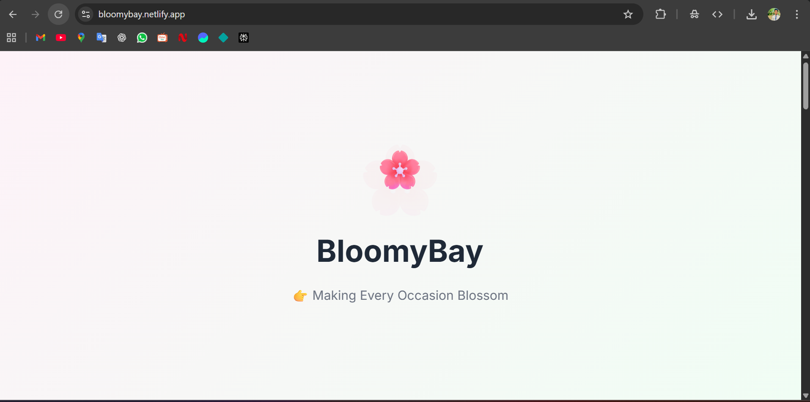

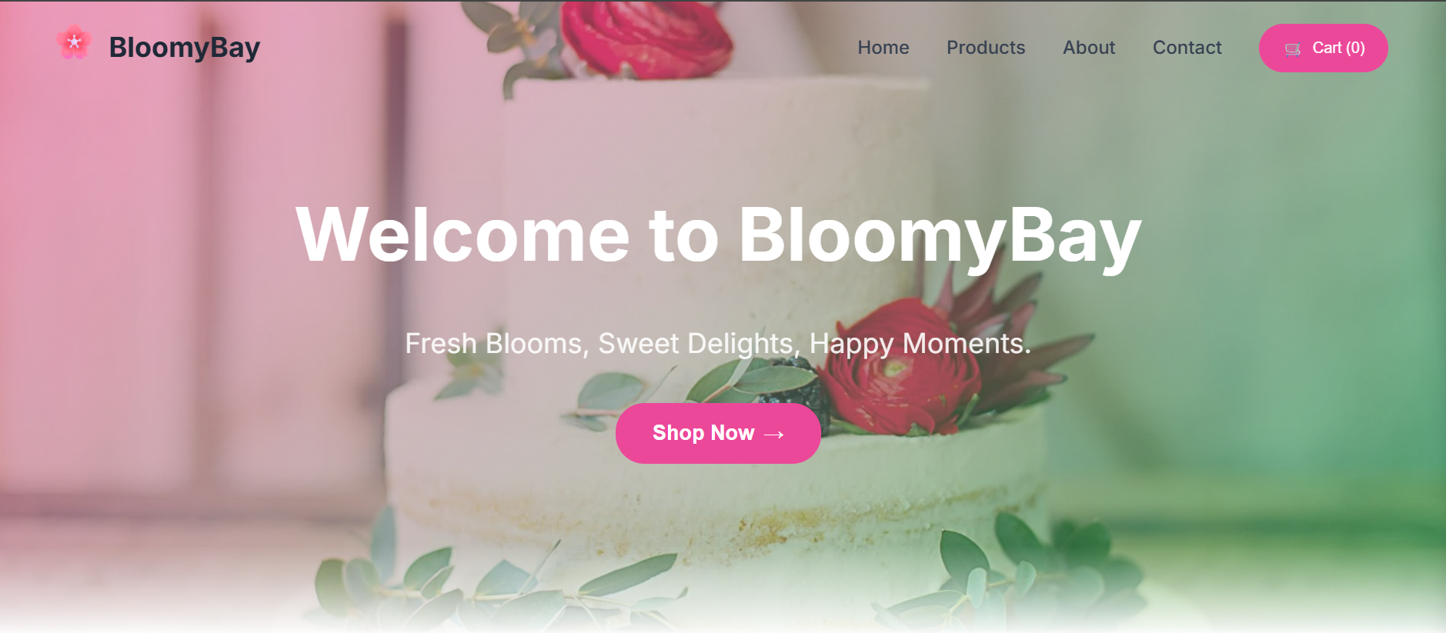

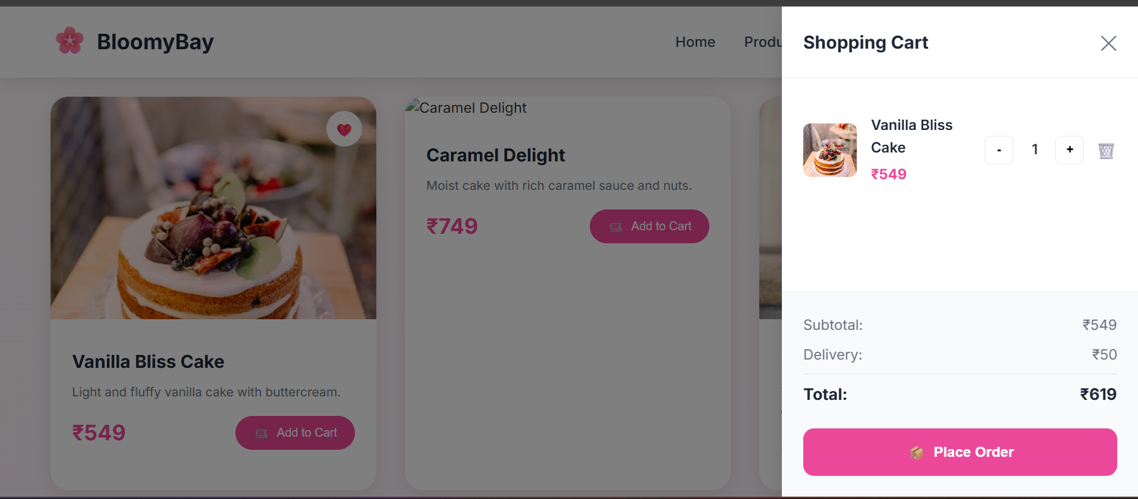
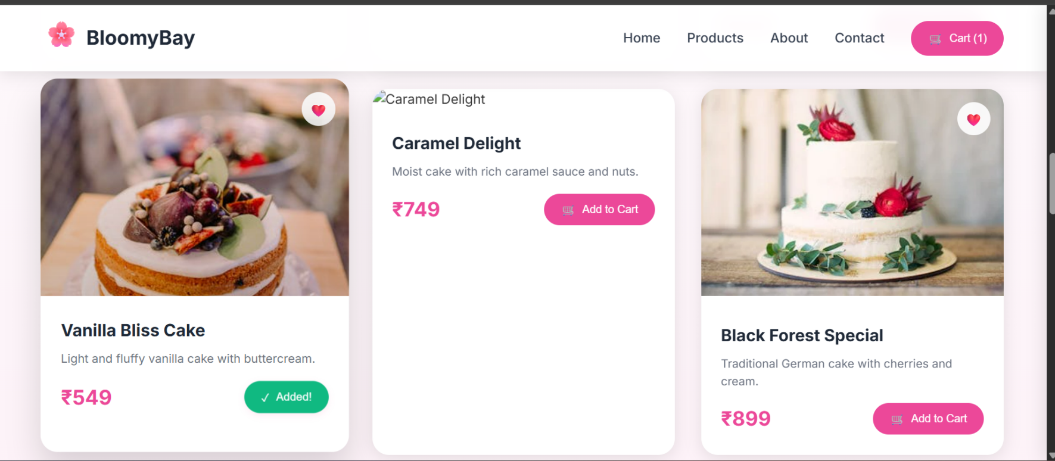
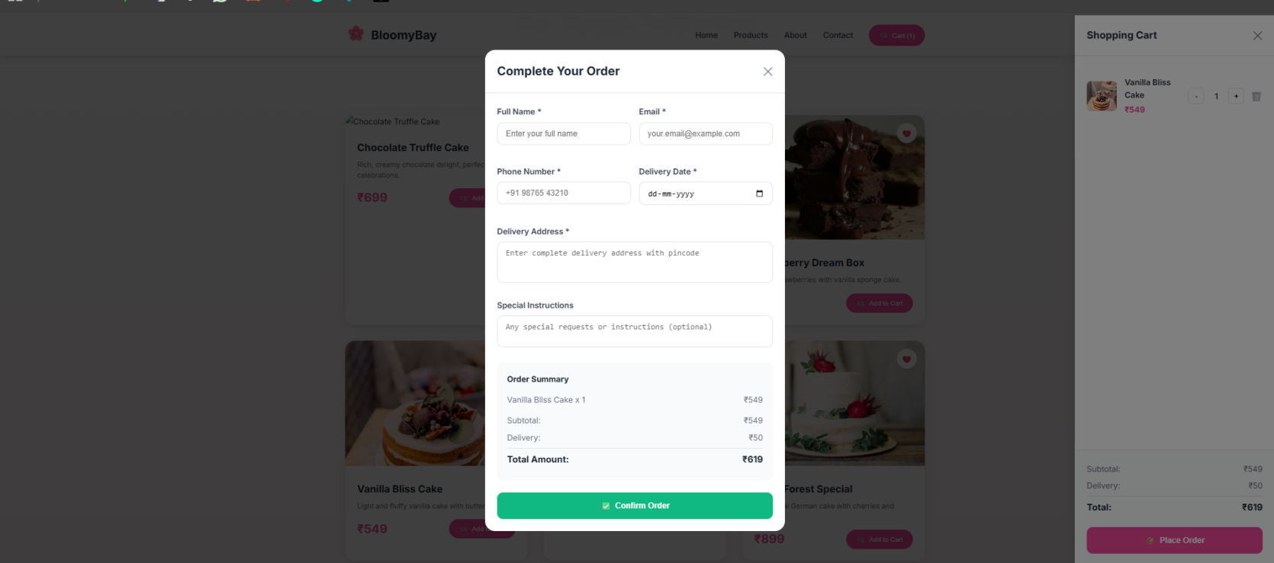

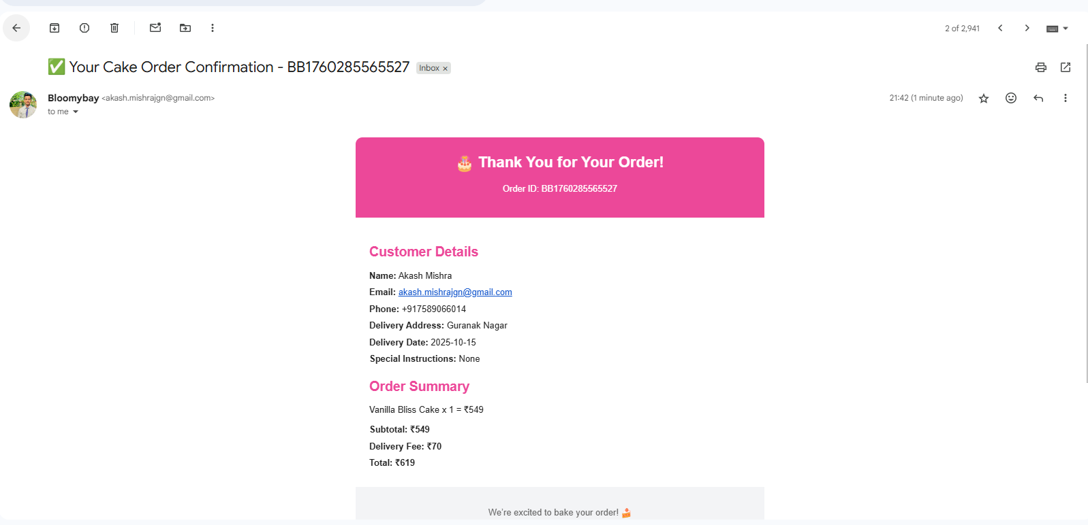

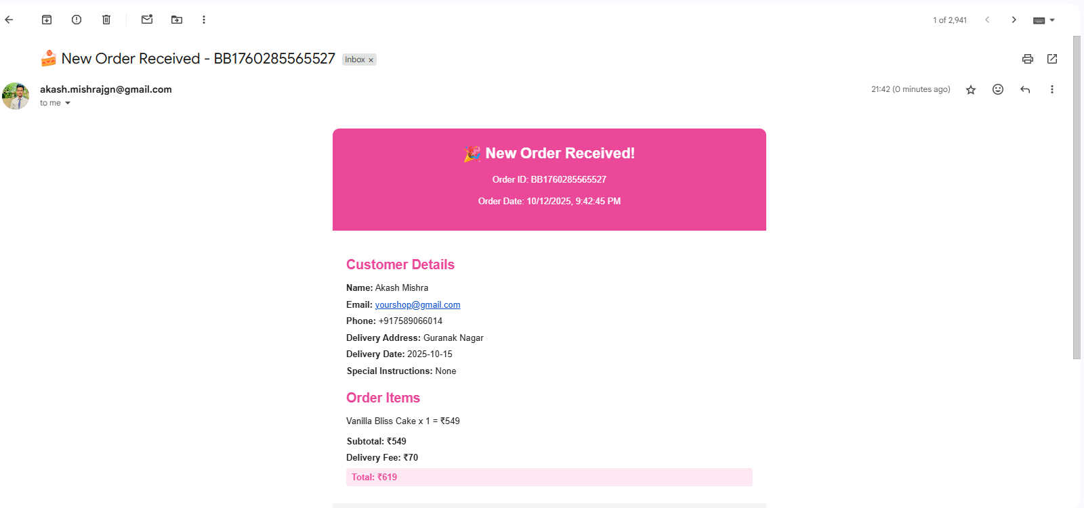

MAINTENANCE
• Regular Data Backup:
Periodic backups are essential to prevent data loss in case of system errors or technical issues during updates.
• Bug Fixes and Updates:
Continuous monitoring is performed to identify and fix bugs, ensuring that all website components function smoothly across different browsers and devices.
• Database Optimization:
Regular optimization of website files and images helps to improve performance and reduce page loading time.
• Security Updates:
Implementation of updated security measures to protect user information and website data from unauthorized access or malware.
• User Support and Training:
Providing ongoing support and guidance to users or team members regarding website navigation, updates, and maintenance activities.
• Monitoring Website Performance:
Regular monitoring of website speed, server response, and uptime to ensure seamless performance and user satisfaction.
• Feedback and Improvements:
Collecting user feedback to make necessary enhancements, ensuring the BloomyBay platform stays user-friendly, visually appealing, and reliable.

CHAPTER-8

CONCLUSION

The BloomyBay project represents an innovative approach to building a user-friendly, visually attractive, and responsive website for online gift and flower delivery. This platform demonstrates the importance of frontend web development in creating a smooth and engaging user experience.
Throughout the project, various web technologies such as HTML, CSS, and JavaScript were effectively used to design and implement different sections of the site. Features such as responsive layouts, interactive navigation menus, and visually appealing product sections contributed to improving overall usability and accessibility.
The project highlights the significance of a clean UI/UX design in enhancing brand presentation and customer engagement. It also showcases how web design principles and coding skills come together to create a functional, real-world application.
In conclusion, BloomyBay stands as a practical example of frontend development, combining creativity and technical skill. Continuous improvement, user feedback, and future integration with backend technologies can further enhance its potential as a professional e-commerce platform.

CHAPTER-9

Bibliography
Topic / Subject | Reference / Author
Web Technologies (HTML, CSS, JS) | By R. Allen Wyke, Jason D. Gilliam & Chariton
Frontend Web Development | By Wrox Publications
Responsive Web Design | By Ethan Marcotte
JavaScript: The Definitive Guide | By David Flanagan
UI/UX Design Principles | By Steve Krug – Don’t Make Me Think
Project Documentation & Reports | By Elias M. Awad

